Day 12

1. **Setup Jenkins Job**
   * Create a new Jenkins pipeline job.
   * Configure the job to pull the Jenkinsfile from the GitHub repository.

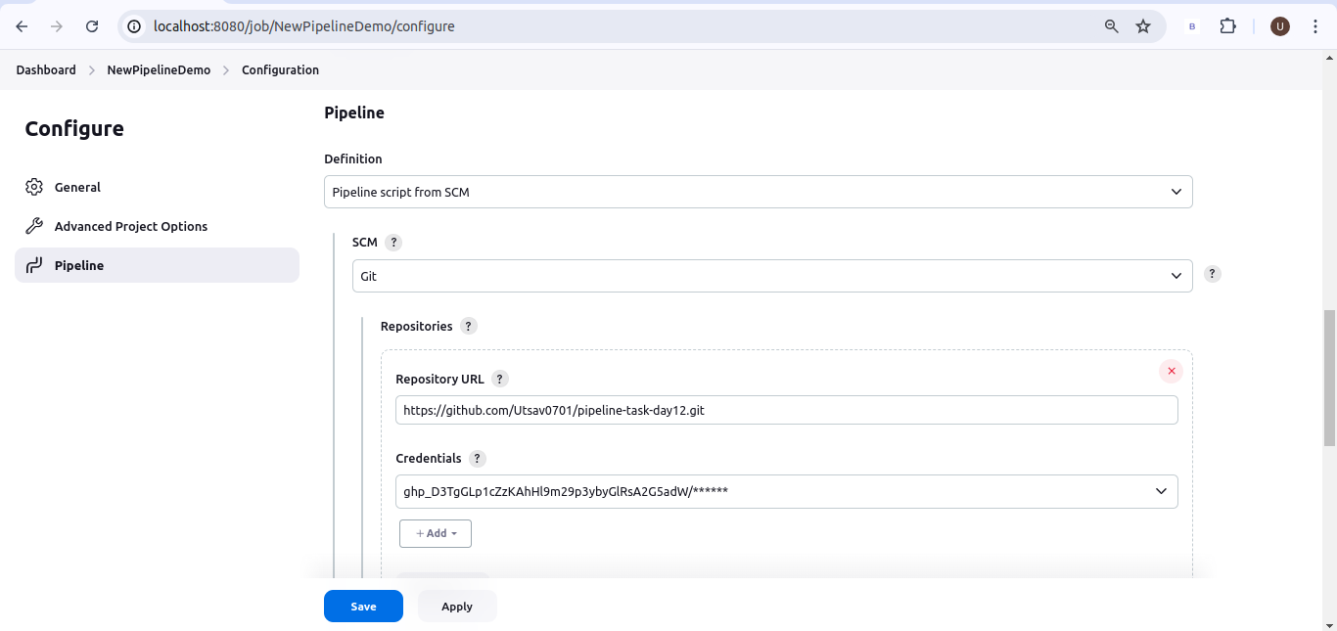.

1. **Create Jenkinsfile**
   * + **Clone Repository**: Clone the Maven project from the GitHub repository.
     + **Build**: Execute the Maven build process (mvn clean install).
     + **Test**: Run unit tests as part of the Maven build.
     + **Archive Artifacts**: Archive the build artifacts for future use.

.

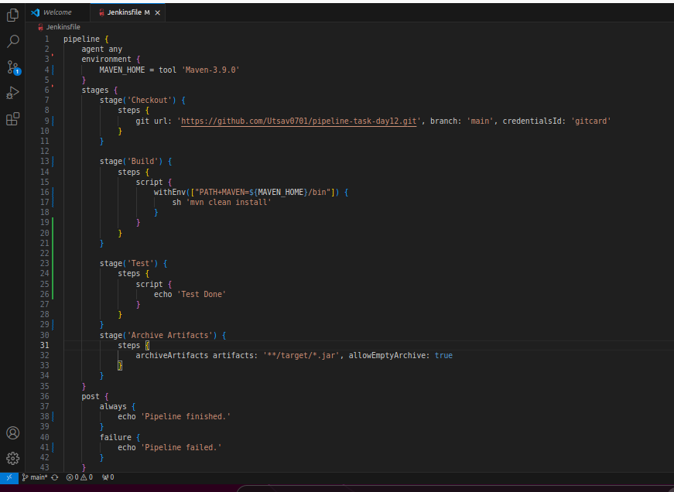.

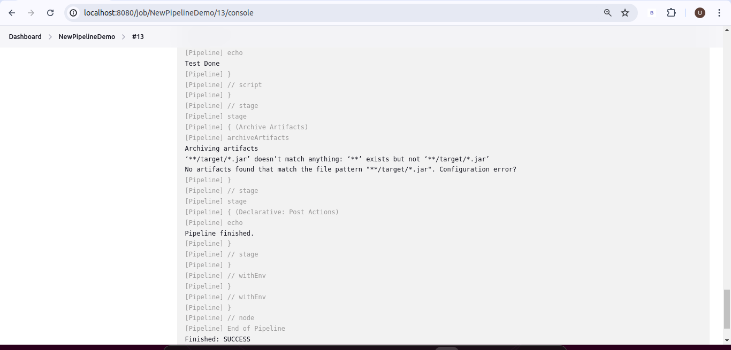.

**3. Configure Pipeline Parameters**

* + Allow the pipeline to accept parameters such as Maven goals and options for flexibility.
  + Ensure the pipeline can be easily modified for different build configurations.

**4. Run the Pipeline**

* + Trigger the Jenkins pipeline job manually or set up a webhook for automatic triggering on GitHub repository changes.
  + Monitor the build process through Jenkins' UI and console output.

